Seismic City
Short  Descriptions | This trip, designed for the Seismolab Earthquake Fellows summer program, is a day-long trip exploring local/regional faults around Pasadena and the local mountains.
Standards  (NGSS) | HS-ESS1-5: Evaluate evidence of the past and current movements of continental and oceanic crust and the theory of plate tectonics to explain the ages of crustal rocks.  HS-ESS2-1: Develop a model to illustrate how Earth’s internal and surface processes operate at different spatial and temporal scales to form continental and ocean-floor features.  Related standard:  SEP2: Developing and Using Models
Learning Outcomes | By the end of the field trip, students will:  - categorize the types of faults (reverse, normal, strike-slip) and relate them to the types of stress (compression, tension, shear)  - recognize faults and earthquake hazards all around them, including in their hometown.  - describe the variability in scale of faults and tectonic features.  - distinguish geologic materials (i.e. soil/alluvial material vs. bedrock) that will result in different responses for a seismometer.
Duration | This trip is a full day trip (9 am – 5 pm); the Eaton Canyon portion of the trip is local, and is ~ 3 hours total.
# students | This trip is designed for 11 students in Caltech GPS Division vehicles. Depending on transportation*, it could be for a full class of ~30 students in a bus (*check bus parking at stops!)
Location (parking) | Stop 1: Loma Alta Park — https://goo.gl/maps/NHciXAntk9hAHxuw9  Stop 2: Tujunga Canyon — https://goo.gl/maps/YrP3s4rqBzidEcXc8  Stop 3: Red Box Gap — https://goo.gl/maps/2vMKUvFs2fTaHKx17  Stop 4: Eaton Canyon — https://goo.gl/maps/gozC2KdiazsmWM4T6  Stop 5: Lacy Park — https://goo.gl/maps/SwJCyGFjdRtVwxmn9
Materials and Equipment | - Pencil/eraser for each student  - Field guide for each student (attached)  - Brunton Compasses  - Laminated poster-sized printout of:  - MAP (google earth) with faults  - Geologic map  - Poster laminated of the VIEW from Eaton Canyon fire road  - Mini whiteboard / whiteboard marker  - Bread of different colors/cheese/etc. for lunchtime sandwich fault activity.  - Nametags for each student  - Snacks & Trash bag (& lunch if full day!)  - First aid and extra sunscreen & hand sanitizer  - Optional: Other guides or local birds / plants
Accessibility | This trip takes place on gravel/dirt surfaces, and includes visual observation of geologic features and maps.  Trails are wide & should be relatively accessible, but are not paved and can be slightly steep.  Adaptations will be necessary to accommodate wheelchairs, difficulties with steep/gravel surfaces, or vision limitations.
Safety Awareness | - Traffic: Do not cross busy roads or walk along roads – drop students at trailheads with a teacher and park vehicles & walk back to students if necessary.  - Watch for and avoid loose rocks on steep slopes above & below you; uneven ground, potential trip hazards & slippery rocks near water  - stream-related safety (near water) at Eaton canyon and Tujunga Wash  - Be aware of poisonous & sharp plants (poison oak, cactuses etc.) and local wildlife (includes rattlesnakes, mountain lions etc.), which are unlikely, but possible!
GO-Outdoors Missions | At GO-Outdoors, we emphasize the following missions:  - Instructor/Caltech volunteer will incorporate 10 Essentials of hiking and Leave No Trace etiquette into the trip and encourage students that they can do these things themselves, to make these concepts approachable.  - We are looking forward to tailor our trips to student interests. At the start of each of our trips, we will ask each student to share what they hope to learn, and we will try to incorporate them into the field trip.
Field trip activities

3 SUV’s, 3 Caltech certified drivers (for 11 students) – pick up Caltech vehicles and park at Arms Circle before the trip, and gather materials, to be ready to load when students arrive!
---------------------------------------------------------------------------------------------------------
8:30 am – Pick up lunches & pack coolers with lunch stuff.
8:45 am – Students arrive at Arms Circle to gather for the trip
9:00 am – Trip begins at Arms Circle! https://goo.gl/maps/PVy7Bnb8EWeZnwmF7

>>Welcome/overview (10 mins) : (could wait and do this at Loma Alta park): Name game, describe the day, bathroom stops, let them know that you have water and first aid supplies and that if they’re ever getting too hot or have any issues, to let instructors know so that we can address issues!

9:10→ Drive to Loma Alta Park (16 min) https://goo.gl/maps/NHciXAntk9hAHxuw9
9:30 am – Stop 1 – Introduction (30 mins)

- Fill out the first page of the guidebook, with compression tension shear & fault types, to review their knowledge. It’s not a test, just to make sure everyone remembers these things!
- Compression–Tension–Shear & Faults: “Stress Field” game (15 mins):
  - Have students get into small groups. Explain that you will be warming up and getting energized for the day with a game that will make sure we all have a good feeling for the types of faults and the types of stresses that relate to them!
  - This will be like a group version of “Red Light, Green Light” but rather than “Red Light”, instructor will be shouting out a stress type, and they will be acting it out in teams. If they mess up, they have to go back to the beginning of the field.
  - Give them 4 minutes to come up with actions/interpretive motions for each of the 3 types of fault, that they can do together as a group when you shout out the stress type.
  - Have students line up on one end of the “Stress Field”; turn around with your back to the students for “Fault Creep!” (“Green Light” in the usual game) where they are able to walk quickly forward as a group towards the end of the field where you are standing. NO RUNNING! (or else the game would end too quickly!)
  - Turn around quickly/randomly, and shout one of the stresses (“Compression”, “Tension”, or “Shear”!) They must stop where they are and act out the type of related fault in their group. If they don’t get the fault type that corresponds to that type of stress, they go back to the beginning of the field!
  - Repeat with other types of stress, variably.
  - Whichever group gets to the end of the field first wins, and acts out a M 8.0 earthquake (their favorite fault to act out); the rest of us have to act out what we would be feeling during the earthquake!

- Introduce the Sierra Madre Fault (15 mins):
  - After the exercise, have students identify and draw where they are on the map in their field guides (p. 4), relative to Pasadena and Sierra Madre Fault, so they are oriented to it (to Loma Alta Park) before we start discussing the site.
  - Helpful: describe hanging wall & footwall:
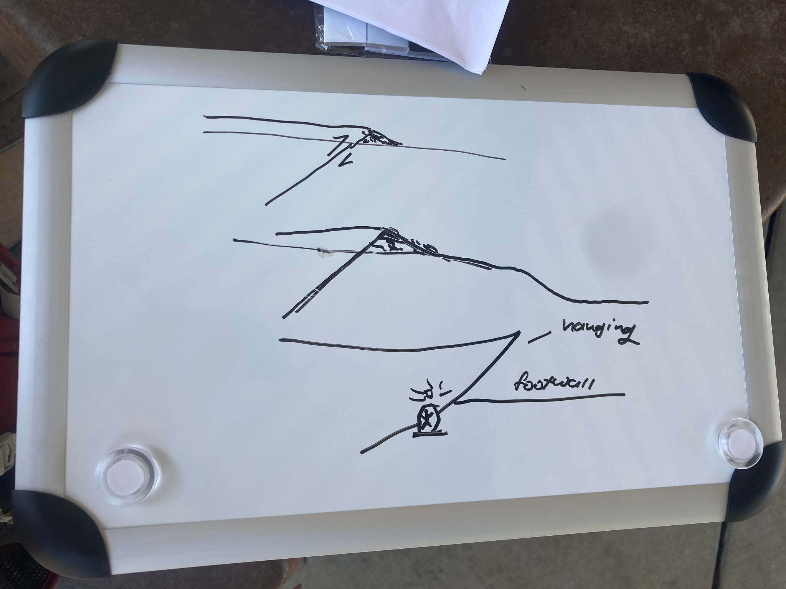
  - Explain the scale of the faults we will be looking at relative to the San Andreas and the likelihood of these faults rupturing in an earthquake within the next 30 years. Mention that we will discuss earthquake statistics and probabilities more later on. Look at the probability on the Sierra Madre Fault relative to the other faults in the LA basin.
  - 1998 Science Paper: describe the trenching they did at Loma Alta park (and what trenching is) and what they were trying to learn. Explain to the students what the figure at the bottom of their Loma Alta page is, what the numbers are, etc. so they understand what they are looking at.
  - Ask the students if they can identify the Sierra Madre fault on the trench cross-section. (On guidebook page)
  - After they have identified the fault, walk them through how this cross-section formed by sketching on the white-board and referencing the figure in their handouts. Explain how this process of thrust faulting forms these step-like geomorphic structures. This is important for knowing how to recognize faults in the landscape (like later when we walk down the Raymond Fault!)
  - Explain the findings in regards to past slip on the Sierra Madre: Rubin et al. (1998) dug trenches here to view the Sierra Madre Fault! They discovered that >4 m of slip happened during each of at least two large, >magnitude 7 earthquakes in the past 15,000 years!
This important discovery brought attention to the potential for large earthquakes in the Los Angeles area!

In field guide: If the Sierra Madre Fault had an earthquake on it, which way would the ground move? What do you think the shaking would feel like right here where we are (e.g., very strong, not noticeable, etc.)?
---------------------------------------------------------------------------------------------------------
10:00 am → Drive to Oro Vista Park (30 min) https://goo.gl/maps/YrP3s4rqBzidEcXc8
10:30 am – Stop 2 – Tujunga Wash (45 min)

- Park in the dirt parking area and hike to the cliffs just past the cement embankment along the creek (north of the parking area). There is a fence here, so you have to find the gap in the fence.
- These cliffs are the scarp of the Tujunga segment of the Sierra Madre thrust fault. Surface ruptures from the 1971 San Fernando earthquake occurred along this zone with up to 1m of displacement!
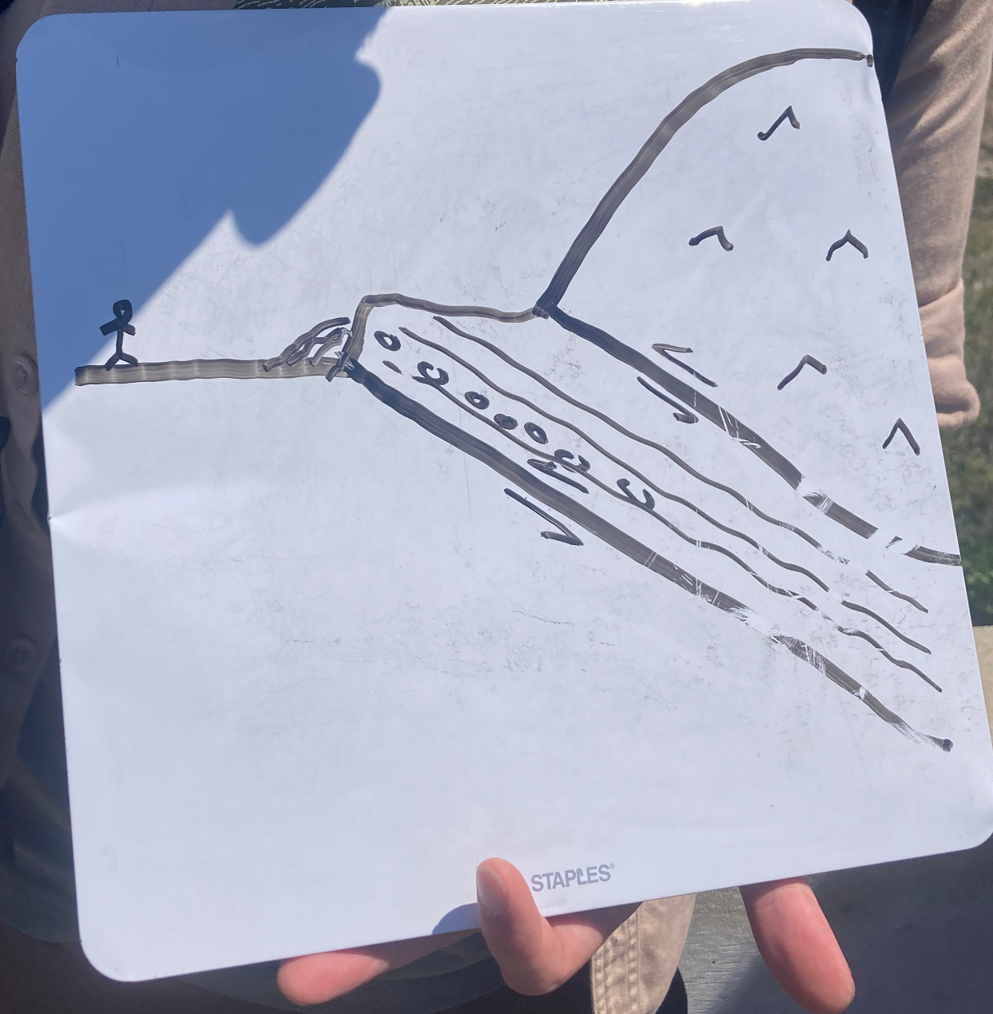
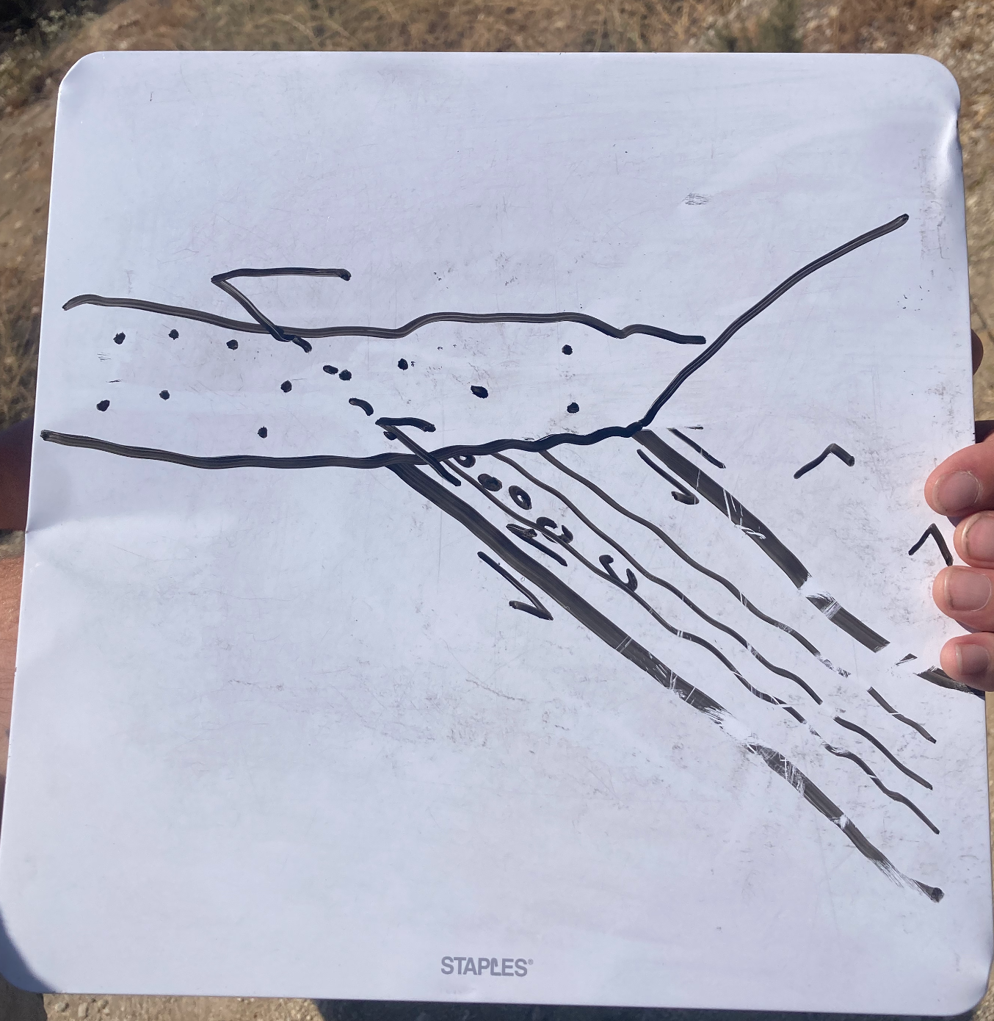
- Point out the fault scarp, describe it (tilted sedimentary beds), and have students sketch what they see in their field guides.
- Locate this fault on the map. Label the sketch you drew in your notebook with the rock units involved in the fault.
- What type of stress created this thrust fault? (Compression!)
- Sketch a cross section using the whiteboard. Have students copy this into their notebooks as well – label rock units like you have in your other sketch, and infer where the crystalline basement would be in the footwall, that we can’t see (not exposed), and where the alluvial material is in the hanging wall.

In field guide: Make a sketch of the fault scarp.
---------------------------------------------------------------------------------------------------------
(OPTIONAL STOP)
Drive to Tujunga Dam Overlook (15 min) https://goo.gl/maps/jqTjpa2ACW44MRti9
Fault in roadcut by Tujunga Dam (20 min)

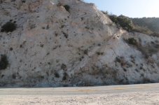
- Can you locate this fault on the map? (maybe not, discuss how faults might be too small to map…)
- Discussion of faults & scales?
- Dam overlook — hazards?

In field guide: extra stop, no page.
---------------------------------------------------------------------------------------------------------
11:15 am → Drive to Red Box Gap (30 min) https://goo.gl/maps/2vMKUvFs2fTaHKx17
11:45 am – Stop 4 – Red Box picnic area – LUNCH (20 min + 40 min to eat)

- San Gabriel Fault! Can you figure out where the fault is? Hint, look for linear features?
- Show the map. Have students locate themselves on the map. Now, can you find the fault?
- Describe the San Gabriel Fault to the group if they haven’t already identified it. The fault runs up the linear canyons to each side of the gap.
- Ask students what type of fault, and stress, do they think it is? (strike-slip, shear).
- Describe the history of San Gabriel Fault as the major plate boundary fault, and that now motion has been transferred to the San Andreas Fault so that this fault is no longer active. See figure on first page of the guidebook that shows where the San Andreas is in relation to where you are.

In field guide: Now, having located yourself on the map compared to stop 1 (and 2): if the Sierra Madre Fault had an earthquake on it, which way would the ground move? What do you think the shaking would feel like right here where we are (e.g., very strong, not noticeable, etc.)?

>> LUNCH
- Lunchtime activity: demonstrate rock layers by building a sandwich with several layers (~4-5?) of different bread types.
  - Cut the bread at an angle, and offset this like a fault. You might prop one side up with an additional piece of bread…
  - Cut the sandwich perpendicular to this fault, possibly in a curved pattern like a stream, representing a canyon downcutting into the land.
  - View the “fault” from the “canyon”, in cross section.
  - Have students describe/sketch this in their notebooks, if there is time.
- While we eat, each student will give a short (~1-2 minute) overview/presentation about what they learned about the earthquake in their assignment. If they had a California earthquake, connect it back to the faults we have seen or are going to see on the trip.

12:30 - 12:50 clean up from lunch, bathrooms, check out/explore around area & crystalline basement rocks etc, group photo!
---------------------------------------------------------------------------------------------------------
12:55 pm → Drive to Eaton Canyon (35 min) https://goo.gl/maps/gozC2KdiazsmWM4T6
1:30 pm – Stop 5 – Eaton Canyon (3 hours)

- (10 min) Drop students with at least one chaperone(s) at Pinecrest gate and have them wait there while drivers park vehicles at spots nearby — make sure spots don’t have No Parking Weekends signs! Walk back to group of students & gather, head count.

- (5 min) Explain that at Eaton Canyon, our local Nature Preserve, we will first go on a hike on a dirt road, which will be most of the elevation down, up and back down. Hiking will last for ~20 minutes up, ~10 minutes down and be sunny, so be prepared for the sun! It might be warm or hot, so remember water. Explain that at the end of this hike, we’ll all go down to the shade by the creek to cool off, and everyone will have a chance to explore and hunt for faults, to find their favorite fault to study in the field!

- (10 min) Walk down the fire road, across the bridge. Along the road before the bridge, note alluvial material exposed in the road cut exposure.
- (5 min) Stop at the rocky outcrop just across the bridge. Describe slickensides, and allow students to explore the outcrop and find slickensides! Feel them, and figure out which way they are oriented. Can you feel which way is smooth vs. rough when you run your hands along them, parallel to their orientation? This will give a sense of which way the fault motion was!
- (10 min) Use Brunton Compasses to measure these features: their strike, dip and the rake of the slickensides. Or, the trend & plunge of the slickensides. Write down measurements on the whiteboard, possibly plot these (estimate/roughly) on a stereonet diagram that you draw on the whiteboard, if students have been previously exposed to stereonets. Take out the map and locate where you now are standing on the overview map. (Find a shady spot, possibly on the bridge).

In field guide: Now, having located ourselves on the map: if the Sierra Madre Fault had an earthquake on it, which way would the ground move? What do you think the shaking would feel like right here where we are (e.g., very strong, not noticeable, etc.)? How do the measurements you have made of the slickensides and features in the rock compare to what you see on the map and what you know about the Sierra Madre Fault?

- ON A HOT DAY: Recommended to skip this next hike up the fire road to see the view, and just use the poster printout of the Google Earth view from nearby, describing that it is what you would have seen from up along the road. The road can be hot, sunny, and exposed!

~2:15 pm
- (10-15 min) Hike up to the second lookout: https://goo.gl/maps/BdYsMCb7PciGiZUR6 to get the best view out over the valley. You will also be hiking basically along the SMF! (It is a fault zone here).
- (5 min) Have students break into small groups or pairs, and point to what faults on the landscape they can see from here. Look out across the valley, and look for hills, particularly linear ones!
- (10 min) Take out laminated photograph (Google Earth image, from Sunset Ridge, to the West of here) of the view across Pasadena from this elevation. As a group, come back together and have students point to locations that they think are faults, and students can trace them on the photo using whiteboard markers!
- (5 min) Get out the Fault Map poster, and compare these fault observations to what is on the map. Can you label any of these faults?
- Update students with the best possible information of faults traced on the landscape (either a printout prepared in advance, or have instructors discuss which ones they think they know for sure). Should be able to see:
  - Sierra Madre Fault (at your feet),
  - Vasquez Creek Fault heading off to the northwest,
  - Raymond Fault crossing Pasadena (low green hills),
  - Eagle Rock Fault (heading out from Raymond Fault, to NW),
  - East Montebello Fault beyond Raymond,
  - maybe faults in the San Rafael Hills,
  - maybe Hollywood Fault, maybe Newport-Inglewood-Rose Canyon fault zone… not sure…
  - probably can’t see this fault, but can see Palos Verdes Hills in the distance and at their base is the Palos Verdes Fault
- In particular, point back to where crystalline basement is in the cliffs above the alluvial deposits that you walked by in the road cut on your way down to the bridge!
- (10 min) Hike back down and turn left down the trail just before the bridge, and turn right onto the Eaton Canyon Falls trail to access the creek, under the bridge.
~3:00
- (10 mins for following points of instruction) Gather in the shade near the creek and explain safety precautions: watch where you step in/around the creek – sticks, slippery rocks, and even gravel can result in tripping and can be knocked to poke or crash into you! Move slowly and carefully if there’s a risk of tripping or slipping.
- Explain that you’ll be hunting in the bedrock walls of the canyon for evidence of past stress and strain in the form of faults! Students will have ~30 minutes to explore up and down the creek in small groups guided by an instructor. There are several different areas with evidence for faulting along the walls of the canyon! In these small groups, instructors will at least take students to see this location, in the outcrops by the second dam/waterfall:
  - 34.194376, -118.104037 https://goo.gl/maps/BZd8gam9usZcA5Qg8
- and, no real need to explore farther than this location:
  - 34.194478, -118.102553 https://goo.gl/maps/jnAbkr73kRZp5YqY6
- 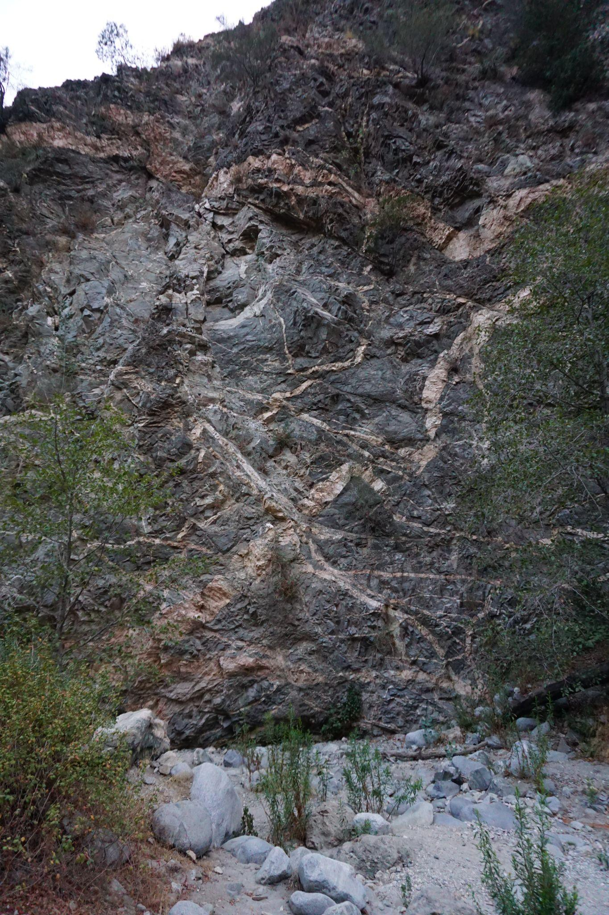
- Finish by explaining that each group will choose one spot where they observed faults (favorite, most understandable, most interesting… etc.) and will sketch that outcrop in their notebooks.
- On their sketches, they should also sketch in where they think the fault plane is, and the sense of motion that they think they observe on the fault. They can write notes about what exactly is being faulted (a layer in the rock? a dike?) Instructors will give guidance.
- Choose a meeting point, and explain that after 30 minutes of exploring, they will have to sketch and return to the chosen meeting point where they are now by X:XX PM (choose a reasonable time, ~45-50 minutes from starting the activity.
- (30 mins) guided exploration of faults along the creek, sketching in notebooks & interpreting fault features & motions on the sketches.
- (15 mins) return to group meeting point!

~4:00
- (10-15 mins) Debrief: What types of offset were observed? What features were offset? How easy was it to tell the sense of motion on the fault? Faults can be very complicated – what was surprising or interesting?
- (~20 mins) Hike back up to the Pinecrest Gate. Instructors pick up vehicles, and pick students up.
---------------------------------------------------------------------------------------------------------
***This stop may need to be skipped depending on timing***
4:30 pm → Drive to Lacy Park (20 min) https://goo.gl/maps/SwJCyGFjdRtVwxmn9
4:50 pm – Stop 6 – Lacy Park (20 min)

- (5 min)Park at the top of the stairs down to Lacy Park. Gather at the top of the stairs, and explain that this is the top of the Raymond Fault!
- (10 min)Allow students to walk down the stairs, and back up, to “feel” the fault offset, physically. It’s a lot!
5:05 pm → Drive back to Caltech, Arms circle (8 min)
Back by 5:15 pm!
---------------------------------------------------------------------------------------------------------
*Optional extension activities

Videos of fault rupture simulations
Stick-slip model of earthquakes: use the hand crank stick-slip simulation
Lessons on seismology, including seismometers and earthquake data

Instructor support
Vocabulary:
Compression:
State of stress and deformation where two blocks of crust are being pushed towards one another. Results in reverse faulting and deformation that includes folding and uplift (e.g. mountain building).
Extension:
State of stress and deformation where two blocks of crust are being pulled in opposite directions (i.e. are in tension). Results in normal faulting and the formation of basins.
Shear:
State of stress and deformation where two blocks of crust slide past one another horizontally. Results in strike-slip (transform) faulting and laterally offset geomorphic features. Shear also occurs on the fault surface itself no matter the faulting type.
Reverse (Thrust) fault:
Faulting type where one block of crust (the hanging wall) is “thrust” up over another block (the footwall). Occurs in a compressive stress state.
Normal fault:
Faulting type where one block of crust (the hanging wall) slides down relative to another block (the footwall). Occurs in a tensile stress state.
Strike-Slip (Transform) fault:
Faulting type where one block of crust slides horizontally past another block without uplift or subsidence of either side. Occurs in a state of shear.
Strike / dip / rake:
Strike: The azimuthal orientation of a line formed by the intersection of an inclined plane (e.g. a bedding plane or fault scarp) with a horizontal plane.
Dip: The angle of the inclined plane from horizontal.
Rake: The direction the hanging wall slips during rupture relative to the strike of the fault.

Resources:
USGS Report: https://pubs.usgs.gov/pp/1339/report.pdf
Geology of Los Angeles: https://www.aegweb.org/assets/docs/la.pdf
CSUN field guide with some fun facts about geology: http://www.csun.edu/science/geoscience/fieldtrips/san-gabriel-mts/san-gabriel-geology.pdf
Quaternary geology & hazards: https://core.ac.uk/download/pdf/216215182.pdf
- Loma Alta Park: trenching site that showed that SoCal could have huge >M7 earthquakes, because of Sierra Madre Fault: 1998 Science paper
https://www.researchgate.net/publication/13618812_Evidence_for_large_earthquakes_in_metropolitan_los_angeles
- earthquake potential of SoCal (Rollins 2019):
https://temblor.net/earthquake-insights/earthquake-potential-of-los-angeles-8370/
(has seismolab animation)
- 3D surfaces & slip rates on major faults in LA basin:
https://www.researchgate.net/publication/228911298_Fault_slip_rates_from_three-dimensional_models_of_the_Los_Angeles_metropolitan_area_California
https://www.aegweb.org/assets/docs/la.pdf
- cross sectional model of compression (Rollins 2018):
https://temblor.net/earthquake-insights/a-tectonic-squeeze-may-be-loading-three-thrust-faults-beneath-central-los-angeles-7749/
Rollins paper: https://agupubs.onlinelibrary.wiley.com/doi/epdf/10.1029/2017JB015387
(original USGS Geology paper: https://earth.usc.edu/~okaya/site/research/pdfs/fuis2001_larse1.pdf )
Community Fault Model: http://dx.doi.org/10.1785/0120050211
Common misconceptions about the concepts

- Faults are planar features (rather than understanding that they are typically distributed zones of deformation)
- Faults can “open” and swallow buildings & people when they rupture
- People (scientists) can predict earthquakes
- We don’t know where faults are/faults cannot be observed in the field
- Land surface is all the same (rather than having different types of rock etc.)
- Shaking will be greater on the footwall than the hanging wall, because it is under more pressure or because it is the block that moves during rupture

*Opportunities to engage students in planning

During the first meeting with students (for Earthquake Fellows), generate a list of questions that students have about faults in the “real world”/in nature, that we can try to target during the trip!

Provided Handouts/Materials
See below!

-Field Guide (9 pages to print)
-Geologic map with faults (printed & laminated in closet)
-Satellite map with faults (printed & laminated in closet)
-Google Earth “View” from Sunset Ridge (printed & laminated in closet)
-Student learning surveys

